1. **What is decision tree? State the advantages and limitations.**

**Introduction:**

A decision tree is a flowchart-like [tree structure](https://www.geeksforgeeks.org/introduction-to-tree-data-structure-and-algorithm-tutorials/) where each internal node denotes the feature, branches denote the rules, and the leaf nodes denote the result of the algorithm.

It is a versatile [supervised machine-learning](https://www.geeksforgeeks.org/ml-types-learning-supervised-learning/) algorithm, which is used for both classification and regression problems.

It is one of the very powerful algorithms.

And it is also used in Random Forest to train on different subsets of training data, which makes random forest one of the most powerful algorithms in [machine learning](https://www.geeksforgeeks.org/machine-learning/).

***Classification based decision trees.***

* Classification is used when the data we have and the data that we are making predictions on are discrete (or) categorical.
* Let's understand the meaning of discrete and continuous data. Ever heard of something like “The system has half defect”? No right! A system either has a complete defect or no defect at all. There are no halves, quarters, or fractions. This type of data is called Discrete data ex: Yes/no, Good/bad, etc. Only a finite number of values are possible, and the values cannot be subdivided further.
* Continuous data is data that can be measured and broken down into smaller parts and still have meaning. Money, temperature, and time are continuous. **Ex:** If you have many pizzas then counting the no. of pizzas is discrete and measuring each pizza and recording the size (i.e., 25.2 cm ,25.2 cm, 26.1cm,26.1 cm, 29.5 cm,29.5 cm, ? *etc.*) that’s continuous data.

***Important Terminologies Related to Decision Trees:***

1. **Root Node**: The root node is the very first node in the tree. This node initiates the whole decision-making process by further getting divided into 2 or more sets of nodes and each node consists of a feature in the data set.
2. **Splitting**: A node is broken down into sub-nodes at every level and this process is called splitting.
3. **Decision Node**: When a node can be broken down into 2 or more nodes then it's called a decision node. This breaking down happens according to the number of different decisions that can be made from that node.
4. **Leaf / Terminal Node**: Nodes that cannot be broken down into sub-nodes anymore.
5. **Pruning**: This is the process of removing an unwanted part of a tree. To be precise it can be a node (or) a branch in the tree too.
6. **Branch / Sub-Tree**: When a tree is split into different sub-parts it is known to be a branch in a tree (or) a subtree.
7. **Parent and Child Node**: When a node is divided into sub-nodes the sub-nodes are called the child nodes and the node that got split is called the parent node of all these child nodes.

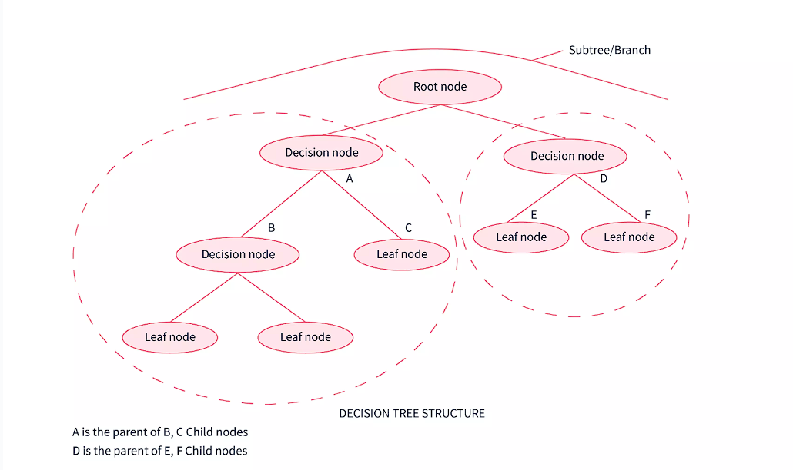

***Why Use Decision Trees?***

Here are some of the reasons that state why we should use decision trees while working on machine learning use cases.

**1)** While using decision trees we get to see the problem more clearly and understand which node is giving rise to what as it forms a tree-like structure. A decision tree almost works like a person doing their day-to-day activities and taking the best decisions related to a certain situation based on various deciding factors.

**2)** Decision trees help us to see all possible cases that a decision can led to and help us make the decision accordingly.

**3)** It helps us in mathematically finding out the probabilities of achieving a certain outcome

**ADVANTAGES**

1. Decision trees can generate understandable rules.

2. Decision trees perform classification without requiring much computation.

3. Decision trees can handle both continuous and categorical variables.

4. Decision trees provide a clear indication of which fields are most important for prediction or classification.

5. **Ease of use:** Decision trees are simple to use and don’t require a lot of technical expertise, making them accessible to a wide range of users.

6. **Scalability:** Decision trees can handle large datasets and can be easily parallelized to improve processing time.

7. **Missing value tolerance:** Decision trees can handle missing values in the data, making them a suitable choice for datasets with missing or incomplete data.

**8. Handling non-linear relationships**: Decision trees can handle non-linear relationships between variables, making them a suitable choice for complex datasets.

**9. Ability to handle imbalanced data:** Decision trees can handle imbalanced datasets, where one class is heavily represented compared to the others, by weighting the importance of individual nodes based on the class distribution.

**DISADVANTAGES**

1. Decision trees are less appropriate for estimation tasks where the goal is to predict the value of a continuous attribute.

2. Decision trees are prone to errors in classification problems with many classes and a relatively small number of training examples.

3. Decision trees can be computationally expensive to train. The process of growing a decision tree is computationally expensive.

4. Decision trees are prone to overfitting the training data, particularly when the tree is very deep or complex.

5. Small variations in the training data can result in different decision trees being generated, which can be a problem when trying to compare or reproduce results.

6. Many decision tree algorithms do not handle missing data well and require imputation or deletion of records with missing values.

7. The initial splitting criteria used in decision tree algorithms can lead to biased trees, particularly when dealing with unbalanced datasets or rare classes.

8. Decision trees are limited in their ability to represent complex relationships between variables, particularly when dealing with nonlinear or interactive effects.

9. Decision trees can be sensitive to the scaling of input features, particularly when using distance-based metrics or decision rules that rely on comparisons between values.

Explain Random Forest Algorithm with example.

* Random Forest is a popular machine learning algorithm that belongs to the supervised learning technique.
* It can be used for both Classification and Regression problems in ML.
* It is based on the concept of **ensemble learning,** which is a process of combining multiple classifiers to solve a complex problem and to improve the performance of the model.
* As the name suggests, ***"Random Forest is a classifier that contains a number of decision trees on various subsets of the given dataset and takes the average to improve the predictive accuracy of that dataset."***
* Instead of relying on one decision tree, the random forest takes the prediction from each tree and based on the majority votes of predictions, and it predicts the final output.
* **The greater number of trees in the forest leads to higher accuracy and prevents the problem of overfitting.**

The below diagram explains the working of the Random Forest algorithm:

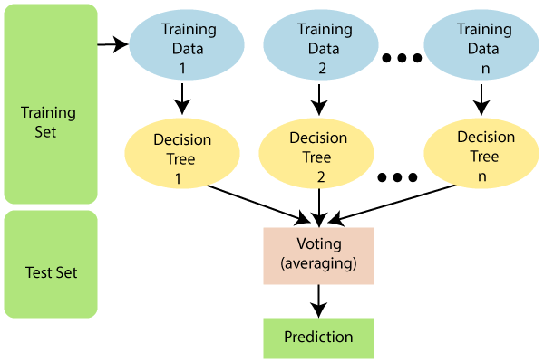

Assumptions for Random Forest

Since the random forest combines multiple trees to predict the class of the dataset, it is possible that some decision trees may predict the correct output, while others may not. But together, all the trees predict the correct output. Therefore, below are two assumptions for a better Random forest classifier:

* There should be some actual values in the feature variable of the dataset so that the classifier can predict accurate results rather than a guessed result.
* The predictions from each tree must have very low correlations.

Why use Random Forest?

Below are some points that explain why we should use the Random Forest algorithm:

<="" li="">

* It takes less training time as compared to other algorithms.
* It predicts output with high accuracy, even for the large dataset it runs efficiently.
* It can also maintain accuracy when a large proportion of data is missing.

## How does Random Forest algorithm work?

Random Forest works in two-phase first is to create the random forest by combining N decision tree, and second is to make predictions for each tree created in the first phase.

The Working process can be explained in the below steps and diagram:

**Step-1:** Select random K data points from the training set.

**Step-2:** Build the decision trees associated with the selected data points (Subsets).

**Step-3:** Choose the number N for decision trees that you want to build.

**Step-4:** Repeat Step 1 & 2.

**Step-5:** For new data points, find the predictions of each decision tree, and assign the new data points to the category that wins the majority votes.

The working of the algorithm can be better understood by the below example:

**Example:** Suppose there is a dataset that contains multiple fruit images. So, this dataset is given to the random forest classifier. The dataset is divided into subsets and given to each decision tree. During the training phase, each decision tree produces a prediction result, and when a new data point occurs, then based on the majority of results, the Random Forest classifier predicts the final decision. Consider the below image:

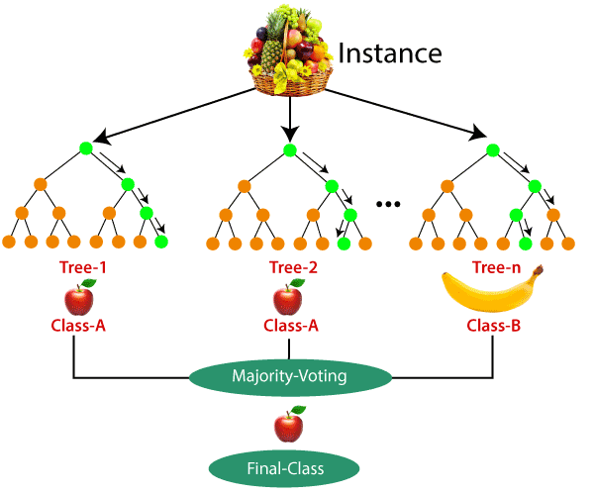

Applications of Random Forest

There are mainly four sectors where Random forest mostly used:

1. **Banking:** Banking sector mostly uses this algorithm for the identification of loan risk.
2. **Medicine:** With the help of this algorithm, disease trends and risks of the disease can be identified.
3. **Land Use:** We can identify the areas of similar land use by this algorithm.
4. **Marketing:** Marketing trends can be identified using this algorithm.

Advantages of Random Forest

* Random Forest is capable of performing both Classification and Regression tasks.
* It is capable of handling large datasets with high dimensionality.
* It enhances the accuracy of the model and prevents the overfitting issue.

Disadvantages of Random Forest

* Although random forest can be used for both classification and regression tasks, it is not more suitable for Regression tasks.

1. **What is the need of decision tree?**
2. Decision trees are a fundamental concept in machine learning, and they have several key advantages that make them a popular choice for many applications. Here are some of the main reasons why decision trees are needed in machine learning:
3. Interpretability: Decision trees provide a transparent and easily interpretable model. The decision-making process is represented as a tree structure, where each node represents a feature and each branch represents a decision based on that feature. This makes it straightforward to understand how the model arrives at its predictions, which is particularly valuable in domains where interpretability is crucial, such as medicine or finance.
4. Feature Selection: Decision trees inherently perform feature selection by identifying the most informative features for splitting the data. Features that lead to the greatest reduction in impurity or increase in information gain are chosen for splitting, allowing the model to focus on the most relevant attributes and ignore irrelevant ones. This helps in improving model efficiency and reducing overfitting.
5. Handling Non-linearity and Interactions: Decision trees are capable of capturing complex nonlinear relationships and interactions between features and the target variable without the need for explicit feature engineering. By recursively partitioning the feature space into regions, decision trees can model intricate decision boundaries, making them suitable for a wide range of data distributions.
6. Robustness to Outliers and Missing Values: Decision trees are robust to outliers and missing values in the data. They can handle noisy or incomplete datasets without significantly impacting their performance. Decision trees can effectively partition the data based on available information at each node, accommodating missing values by choosing the most probable path.
7. Scalability: Decision trees are computationally efficient and scalable, particularly for datasets with a large number of features or instances. The time complexity of training and predicting with decision trees is typically logarithmic in the number of instances and features, making them suitable for large-scale applications.
8. Ensemble Methods: Decision trees serve as the foundation for powerful ensemble methods such as Random Forests, Gradient Boosting Machines (GBMs), and AdaBoost. By combining multiple decision trees, ensemble methods can further enhance predictive accuracy, robustness, and generalization performance.
9. **Explain decision trees algorithm.**
10. **Decision Tree Construction:**

* Starting Point: The decision tree construction starts with the entire dataset at the root node.
* Feature Selection: At each node, the algorithm selects the best feature that splits the data into subsets that are as pure as possible in terms of the target variable (e.g., minimizing entropy or Gini impurity for classification, minimizing variance for regression).
* Splitting: The dataset is split into two or more subsets based on the chosen feature. Each subset corresponds to a branch stemming from the current node.
* Recursive Partitioning: This process of selecting the best feature and splitting the dataset is applied recursively to each subset until one of the stopping criteria is met (e.g., maximum tree depth, minimum number of samples per leaf node).

1. **Stopping Criteria:**

* Maximum Depth: The tree stops growing when it reaches a maximum depth specified by the user.
* Minimum Samples per Leaf: Nodes are not split if the number of samples in the node falls below a certain threshold.
* Maximum Number of Leaf Nodes: The tree stops growing when it reaches a maximum number of leaf nodes.
* Minimum Impurity Decrease: Nodes are not split if the impurity decrease (or increase in information gain) is below a certain threshold.

1. **Tree Pruning (Optional):**

* After the tree is fully grown, pruning techniques may be applied to reduce overfitting. Pruning involves removing nodes that do not significantly improve predictive accuracy on a validation set while keeping the overall structure of the tree intact.

1. **Prediction:**

* To make a prediction for a new instance, the algorithm traverses the decision tree from the root node to a leaf node based on the values of the features of the instance. The predicted target variable is the majority class (for classification) or the mean value (for regression) of the instances in the leaf node.

1. **Handling Categorical Features:**

* For categorical features, the decision tree algorithm typically uses one-hot encoding or binary encoding to represent each category as a binary value.

1. **Handling Missing Values:**

* Decision trees can handle missing values in the dataset. During the tree construction process, if a feature value is missing for an instance, the algorithm can choose a path based on the available feature values or assign a probability to each branch based on the distribution of the feature values in the training data.

1. **Ensemble Methods:**

* Decision trees can also be used as building blocks for ensemble methods like Random Forests and Gradient Boosting Machines (GBMs). Ensemble methods combine multiple decision trees to improve predictive performance, robustness, and generalization.

1. **What is information gain entropy in decision tree?**

## What is the information gain in Entropy?

Information gain is defined as the pattern observed in the dataset and reduction in the entropy.

Mathematically, information gain can be expressed with the below formula:

Information Gain = (Entropy of parent node)-(Entropy of child node)

#### **Note: Information gain is calculated as 1-Entropy.**

Let's understand it with an example having three scenarios as follows:

|  |  |  |
| --- | --- | --- |
|  | **Entropy** | **Information Gain** |
| Scenario 1 | 0.7812345 | 0.2187655 |
| Scenario 2 | 0 | 1 |
| Scenario 3 | 1 | 0 |

Let's say we have a tree with a total of four values at the root node that is split into the first level having one value in one branch (say, Branch 1) and three values in the other branch (Branch 2). The entropy at the root node is 1.

Now, to compute the entropy at the child node 1, the weights are taken as ? for Branch 1 and ? for Branch 2 and are calculated using Shannon's entropy formula. As we had seen above, the entropy for child node 2 is zero because there is only one value in that child node, meaning there is no uncertainty, and hence, the heterogeneity is not present.

H(X) = - [(1/3 * log2 (1/3)) + (2/3 * log2 (2/3))] = 0.9184

The information gain for the above case is the reduction in the weighted average of the entropy.

Information Gain = 1 - ( ¾ * 0.9184) - (¼ *0) = 0.3112

The more the entropy is removed, the greater the information gain. The higher the information gain, the better the split.

## How to build decision trees using information gain:

After understanding the concept of information gain and entropy individually now, we can easily build a decision tree. See steps to build a decision tree using information gain:

1. An attribute with the highest information gain from a set should be selected as the parent (root) node. From the image below, it is attributed A.  
   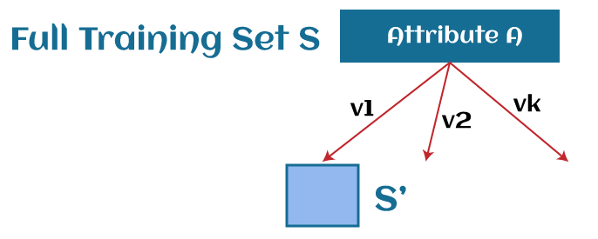
2. Build child nodes for every value of attribute A.
3. Repeat iteratively until you finish constructing the whole tree.

### **Advantages of the Decision Tree:**

* A decision tree can be easily understandable as it follows the same process of human thinking while making any decision.
* It is used to solve any decision-related problem in machine learning.
* It helps in finding out all the possible outcomes for a problem.
* There is less requirement for data cleaning compared to other algorithms.

1. **Which are algorithms used in decision tree?**

* **ID3** : ID3 stands for *Iterative Dichotomiser 3* . This algorithm iteratively divides features into two or more groups at each step. Here "Iterative" means continuous/repeated and "dichotomiser" means dividing. ID3 follows a top-down approach i.e., the tree is built from the top and at every step greedy approach is applied. The greedy approach means that at each iteration we select the best feature now to create a node and this node is again split after applying some statistical methods. ID3 generally is not a very ideal algorithm as it overfits when the data is continuous.
* **CART**: CART stands for classification and regression trees. As the name suggests CART can also perform both classification and regression-based tasks. CART uses Gini’s impurity index as an attribute selection method while splitting a node into further nodes when it's a classification-based use case and uses sum squared error as an attribute selection measure when the use case is regression-based. While CART uses Gini Index as an ASM(attribute selection measure), C4.5 and ID3 use information gain as an ASM.
* **CHAID**: CHAID stands for Chi-square Automatic Interaction Detector. It is known to be the oldest of all three algorithms in history and is used very less these days. In CHAID chi-square is the attribute selection measure to split the nodes when it's a classification-based use case and uses F-test as an attribute selection measure when it is a regression-based use case. Higher the chi-square value higher is the preference given to that feature. The major difference between CHAID and CART is, CART splits one node into two nodes whereas CHAID splits one node into 2 or more nodes.
* **MARS**: MARS stands for Multivariate adaptive regression splines. It is an algorithm that was specifically designed to handle regression-based tasks, provided, the data is non-linear.
* **C4.5**: It is better than the ID3 algorithm as it can handle both discrete and continuous data. In C4.5 splitting is done based on Information gain (attribute selection measure ) and the feature with the highest Information gain is made the decision node and is further split. C4.5 handles overfitting by the method of pruning i.e it removes the branches/subpart of the tree that does not hold much importance (or) is redundant. To be specific, C4.5 follows post pruning i.e removing branches after the tree is created.

1. **What is SVM? Explain in detail.**

Support Vector Machine :

Support Vector Machine (SVM) is a supervised machine learning algorithm used for both classification and regression. Though we say regression problems as well it’s best suited for classification. The main objective of the SVM algorithm is to find the optimal hyperplane in an N-dimensional space that can separate the data points in different classes in the feature space. The hyperplane tries that the margin between the closest points of different classes should be as maximum as possible. The dimension of the hyperplane depends upon the number of features. If the number of input features is two, then the hyperplane is just a line. If the number of input features is three, then the hyperplane becomes a 2-D plane. It becomes difficult to imagine when the number of features exceeds three.

Let’s consider two independent variables x1, x2, and one dependent variable which is either a blue circle or a red circle.

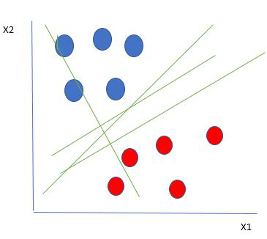

From the figure above it’s very clear that there are multiple lines (our hyperplane here is a line because we are considering only two input features x1, x2) that segregate our data points or do a classification between red and blue circles. So how do we choose the best line or in general the best hyperplane that segregates our data points?

One reasonable choice as the best hyperplane is the one that represents the largest separation or margin between the two classes.

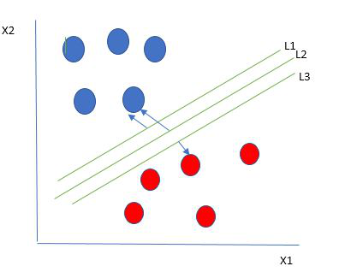

So, we choose the hyperplane whose distance from it to the nearest data point on each side is maximized. If such a hyperplane exists it is known as the **maximum-margin hyperplane/hard margin**. So, from the above figure, we choose L2. Let’s consider a scenario like shown below

* 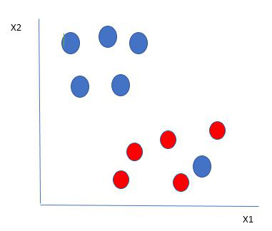

Here we have one blue ball in the boundary of the red ball. So how does SVM classify the data? It’s simple! The blue ball in the boundary of red ones is an outlier of blue balls. The SVM algorithm has the characteristics to ignore the outlier and finds the best hyperplane that maximizes the margin. SVM is robust to outliers.

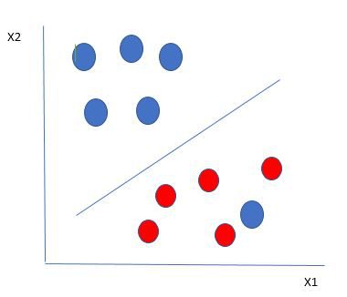

So, in this type of data point what SVM does is, finds the maximum margin as done with previous data sets along with that it adds a penalty each time a point crosses the margin. So, the margins in these types of cases are called soft margins. When there is a soft margin to the data set, the SVM tries to minimize (1/margin+∧(∑penalty)). Hinge loss is a commonly used penalty. If no violations no hinge loss. If violations hinge loss proportional to the distance of violation.

Till now, we were talking about linearly separable data(the group of blue balls and red balls are separable by a straight line/linear line). What to do if data are not linearly separable?

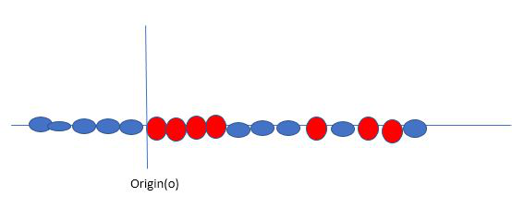

Say, our data is shown in the figure above. SVM solves this by creating a new variable using a kernel. We call a point xi on the line, and we create a new variable Yi as a function of distance from origin o.so if we plot this, we get something like as shown below

In this case, the new variable y is created as a function of distance from the origin. A non-linear function that creates a new variable is referred to as a kernel.

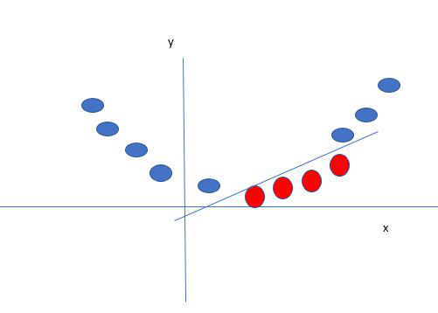

*Mapping 1D data to 2D to become able to separate the two classes*

**The below info.is from ChatGPT:**

Support Vector Machine (SVM) is a type of supervised learning algorithm used in machine learning to solve classification and regression problems. It’s particularly effective in solving binary classification problems, which require classifying the elements of a data set into two groups. The goal of SVM is to find a hyperplane that best separates the data into two classes.

Here’s a step-by-step explanation of how SVM works:

Data Preprocessing: The data is first preprocessed to convert it into a format that can be used by the SVM algorithm. This includes tasks such as feature scaling, normalization, and handling missing values.

Training: The SVM algorithm is then trained on the preprocessed data. The training data is divided into two main parts: support vectors and non-support vectors. Support vectors are the data points that are closest to the hyperplane, while non-support vectors are the data points that are farther away from the hyperplane.

Hyperplane Selection: The SVM algorithm then selects a hyperplane that separates the support vectors into two classes. This hyperplane is chosen such that it maximizes the margin between the two classes, which is the distance between the hyperplane and the nearest support vector.

Kernel Trick: To handle non-linearly separable data, SVM uses the kernel trick. This involves transforming the data into a higher-dimensional space where it becomes linearly separable. The kernel function is used to compute the dot products between the transformed feature vectors, which enables the SVM to implicitly compute the dot products and avoid handling expensive, unnecessary computations for extreme cases.

Prediction: Once the SVM model is trained, it can be used to make predictions on new, unseen data. The model uses the hyperplane to classify the new data into one of the two classes.

SVMs are useful for analyzing complex data that can’t be separated by a simple straight line. They can handle both linearly separable and non-linearly separable data by using different types of kernel functions, such as the linear kernel, polynomial kernel, or radial basis function (RBF) kernel. These kernel functions enable SVMs to effectively capture complex relationships and patterns in the data.

SVMs have many applications in various fields, including text classification, image recognition, and handwritten digit recognition. They are particularly effective in tasks such as spam detection, sentiment analysis, and aspect-based recognition.

1. **Explain Hyperplane and Support Vectors in the SVM algorithm.**

# **Support Vector Machine Algorithm**

Support Vector Machine or SVM is one of the most popular Supervised Learning algorithms, which is used for Classification as well as Regression problems. However, primarily, it is used for Classification problems in Machine Learning.

The goal of the SVM algorithm is to create the best line or decision boundary that can segregate n-dimensional space into classes so that we can easily put the new data point in the correct category in the future. This best decision boundary is called a hyperplane.

SVM chooses the extreme points/vectors that help in creating the hyperplane. These extreme cases are called as support vectors, and hence algorithm is termed as Support Vector Machine. Consider the below diagram in which there are two different categories that are classified using a decision boundary or hyperplane:

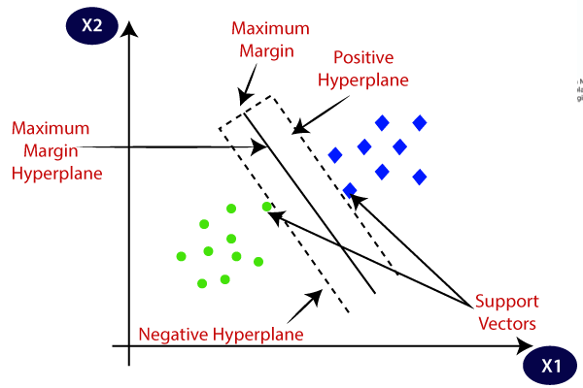Hyperplane and Support Vectors in the SVM algorithm:

**Hyperplane:** There can be multiple lines/decision boundaries to segregate the classes in n-dimensional space, but we need to find out the best decision boundary that helps to classify the data points. This best boundary is known as the hyperplane of SVM.

The dimensions of the hyperplane depend on the features present in the dataset, which means if there are 2 features (as shown in image), then hyperplane will be a straight line. And if there are 3 features, then hyperplane will be a 2-dimension plane.

We always create a hyperplane that has a maximum margin, which means the maximum distance between the data points.

Definition: A hyperplane in an n-dimensional space is a flat affine subspace of dimension n−1. In the context of SVM, a hyperplane is a decision boundary that separates the data points of different classes in the feature space.

Linear Separation: In a binary classification problem, the hyperplane divides the feature space into two regions, with each region corresponding to a different class label. If the data points are linearly separable, there exists at least one hyperplane that perfectly separates the two classes.

Equation: Mathematically, a hyperplane in an n-dimensional space can be represented by the equation:

w⋅x+b=0

where w is the normal vector to the hyperplane (weights), x is the input feature vector, and b is the bias or intercept term.

Margin: The distance between the hyperplane and the closest data points from each class is known as the margin. The optimal hyperplane in SVM is the one that maximizes this margin.

**Support Vectors:**

The data points or vectors that are the closest to the hyperplane and which affect the position of the hyperplane are termed as Support Vector. Since these vectors support the hyperplane, hence called a Support vector.

Definition: Support vectors are the data points that lie closest to the hyperplane and determine its position. They are the critical points that define the margin of the SVM classifier.

Importance: In SVM, only the support vectors are used in the construction of the hyperplane, while the other data points are ignored. This property makes SVM memory efficient and suitable for large datasets.

Margin Support Vectors: Support vectors lying exactly on the margin contribute to the determination of the hyperplane's position. These are known as margin support vectors and have a non-zero Lagrange multiplier in the optimization problem associated with SVM.

Non-margin Support Vectors: Support vectors lying inside the margin or on the wrong side of the hyperplane (misclassified) are called non-margin support vectors. They also influence the position of the hyperplane but to a lesser extent.

How does SVM works?

**Linear SVM:**

The working of the SVM algorithm can be understood by using an example. Suppose we have a dataset that has two tags (green and blue), and the dataset has two features x1 and x2. We want a classifier that can classify the pair(x1, x2) of coordinates in either green or blue. Consider the below image:

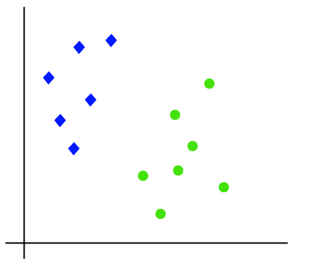

So as it is 2-d space so by just using a straight line, we can easily separate these two classes. But there can be multiple lines that can separate these classes. Consider the below image:

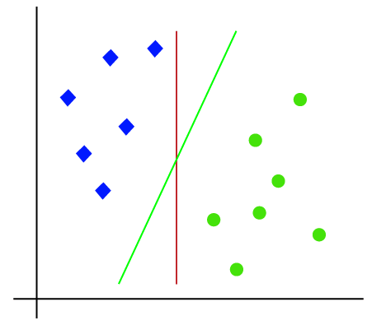

Hence, the SVM algorithm helps to find the best line or decision boundary; this best boundary or region is called as a **hyperplane**. SVM algorithm finds the closest point of the lines from both the classes. These points are called support vectors. The distance between the vectors and the hyperplane is called as **margin**. And the goal of SVM is to maximize this margin. The **hyperplane** with maximum margin is called the **optimal hyperplane**.

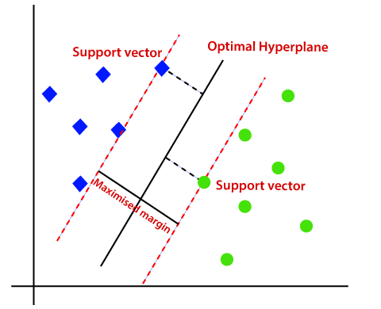

**Non-Linear SVM:**

If data is linearly arranged, then we can separate it by using a straight line, but for non-linear data, we cannot draw a single straight line. Consider the below image:

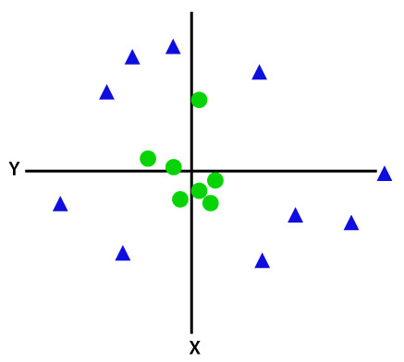

So to separate these data points, we need to add one more dimension. For linear data, we have used two dimensions x and y, so for non-linear data, we will add a third dimension z. It can be calculated as:

z=x2 +y2

By adding the third dimension, the sample space will become as below image:

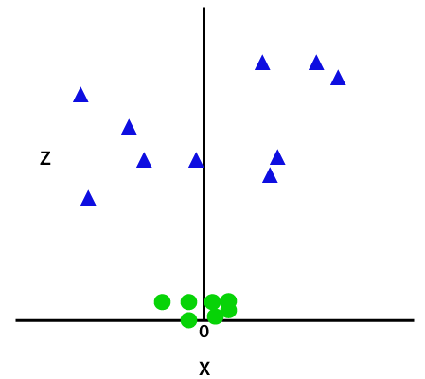

So now, SVM will divide the datasets into classes in the following way. Consider the below image:

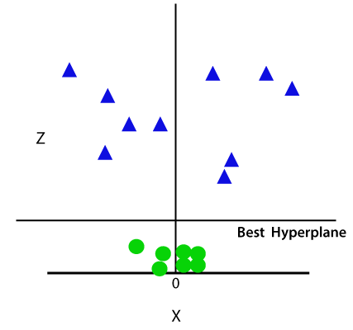

Since we are in 3-d Space, hence it is looking like a plane parallel to the x-axis. If we convert it in 2d space with z=1, then it will become as:

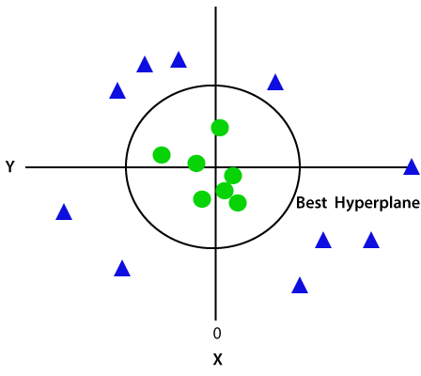

Hence we get a circumference of radius 1 in case of non-linear data.

1. **Which are the Pros and Cons of SVM Classifiers?**

**Advantages of SVMs**

SVMs are powerful machine learning algorithms that have the following advantages:

* **Effective in high-dimensional spaces.** High-dimensional data refers to data in which the number of features is larger than the number of observations, i.e., data points. SVMs perform well even when the number of features is larger than the number of samples. They can handle high-dimensional data efficiently, making them suitable for applications with a large number of features.
* **Resistant to overfitting.** SVMs are less prone to overfitting compared to other algorithms, like decision trees -- overfitting is where a model performs extremely well on the training data but becomes too specific to that data and can't generalize to new data. SVMs' use of the margin maximization principle helps in generalizing well to unseen data.
* **Versatile.** SVMs can be applied to both classification and regression problems. They support different kernel functions, enabling flexibility in capturing complex relationships in the data. This versatility makes SVMs applicable to a wide range of tasks.
* **Effective in cases of limited data.** SVMs can work well even when the training data set is small. The use of support vectors ensures that only a subset of data points influences the decision boundary, which can be beneficial when data is limited.
* **Ability to handle nonlinear data.** SVMs can implicitly handle non-linearly separable data by using kernel functions. The kernel trick enables SVMs to transform the input space into a higher-dimensional feature space, making it possible to find linear decision boundaries.

**Disadvantages of SVMs**

While support vector machines are popular for the reasons listed above, they also come with some limitations and potential issues:

* **Computationally intensive.** SVMs can be computationally expensive, especially when dealing with large data sets. The training time and memory requirements increase significantly with the number of training samples.
* **Sensitive to parameter tuning.** SVMs have parameters such as the regularization parameter and the choice of kernel function. The performance of SVMs can be sensitive to these parameter settings. Improper tuning can lead to suboptimal results or longer training times.
* **Lack of probabilistic outputs.** SVMs provide binary classification outputs and do not directly estimate class probabilities. Additional techniques, such as Platt scaling or cross-validation, are needed to obtain probability estimates.
* **Difficulty in interpreting complex models.** SVMs can create complex decision boundaries, especially when using nonlinear kernels. This complexity may make it challenging to interpret the model and understand the underlying patterns in the data.
* **Scalability issues.** SVMs may face [scalability](https://www.techtarget.com/searchstorage/answer/How-do-storage-scalability-and-elasticity-differ) issues when applied to extremely large data sets. Training an SVM on millions of samples can become impractical due to memory and computational constraints.

**Pros of SVM Classifiers:megrv mvger**

1. **Effective in High-Dimensional Spaces:** SVM performs well in datasets with a large number of features, making it suitable for tasks like text classification, image recognition, and bioinformatics.
2. **Memory Efficient:** SVM uses only a subset of training points as support vectors, making it memory efficient for large datasets. This property is especially valuable when dealing with high-dimensional data.
3. **Versatile Kernel Functions:** SVM can handle both linearly separable and non-linearly separable data by using different kernel functions. Common kernel functions include linear, polynomial, radial basis function (RBF), and sigmoid kernels.
4. **Robust to Overfitting:** SVM has regularization parameters that help prevent overfitting, making it robust to noisy data. By controlling the trade-off between maximizing the margin and minimizing classification errors, SVM can generalize well to unseen data.
5. **Global Optimality:** SVM optimization is a convex optimization problem, which means that it has a unique global minimum. This property ensures that the solution found by SVM is optimal and not sensitive to initialization or local optima.
6. **Effective for Small to Medium-Sized Datasets:** SVM tends to perform well on small to medium-sized datasets, especially when the number of features is comparable to the number of samples.

**Cons of SVM Classifiers:**

1. **Computationally Intensive:** Training SVM can be computationally intensive, especially for large datasets or datasets with a high number of features. The training time complexity of SVM is typically between 𝑂(𝑛2×𝑑) and O(n3×d), where n is the number of samples and d is the number of features.
2. **Parameter Selection:** SVM has parameters like the regularization parameter (C) and the choice of kernel function that need to be carefully tuned. Finding the optimal values for these parameters can be challenging and may require extensive experimentation.
3. **Limited Interpretability:** SVM models are often less interpretable compared to simpler models like decision trees or linear regression. The decision boundary in SVM is defined by a complex hyperplane in the feature space, making it difficult to interpret the relationship between input features and the target variable.
4. **Memory Requirements:** While SVM is memory efficient in terms of storing support vectors, the size of the model can still be large, especially when using non-linear kernels or when the dataset has a large number of support vectors.
5. **Difficulty with Large Datasets:** SVM may struggle with very large datasets due to its computational complexity and memory requirements. In such cases, approximate solutions or parallelization techniques may be necessary to scale SVM to large-scale datasets.
6. **What is the kernel trick in SVM?**